
Ecumenic Ecomuseum
Interfaith-Based Laic-Compliant Creativity
Compassionate Ethic Sustainable Peacebuilding Inclusive Collaborative Open-Source Art
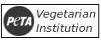

https://ecumenic.github.io
◇
https://ecumenic.github.io
Copyright © Ecumenic Creative Operations 2019
Creative Commons License [ CC BY-NC-SA 4.1. ]
Version 0.7

[PG] Parental (Or Responsible) Guidance Recommended

The royalties of this edition are assigned by the authors to the Ecumenic Creative Operations.

The opinions expressed in this book are those of the Ecumenic Creative Operations
and do not necessarily represent the position of institutions or persons involved in its production.

Respect the nature printing wisely.

Cover: The Roerich Pact Peace Culture Banner inside the Red Cross III Protocol interfaith-based laic-compliant
assistance diamond above the United Nations peacebuilding olive branch.

Cataloging In Publication International Data (CIP):
ts700.66e Ecumenic Creative Operations: Interfaith-Based Laic-Compliant Collaborative Artwork Project
/ Ribeiro, Felipe: Organizator. São Paulo, Brazil. Ecumenic Creative Operations, 2019.
Areas of Interest: 1.Art Project. 2.Reliability Engineering. 3. Culture Studies. 4.Data-Analysis.



"Et audi ad ea pages."
Ecumenic Ecomuseum
Interfaith-Based Laic-Compliant Creativity
◇
Contents

1. Project:...........................................4
1.1. Proposal
1.2. A
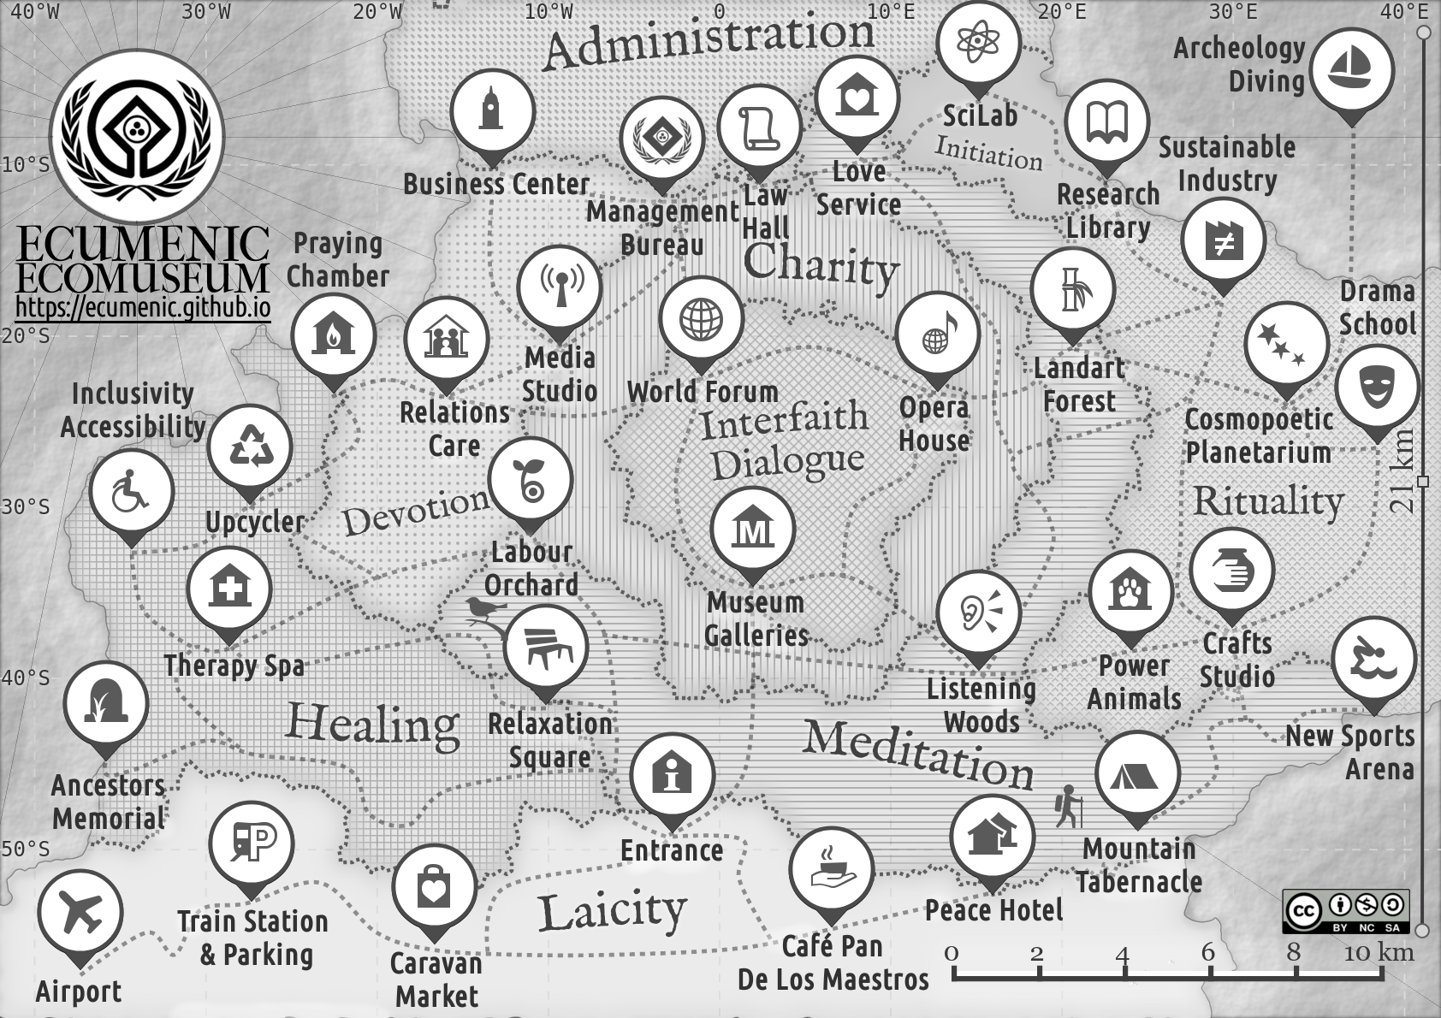
1. Project:

1.1. Proposal:

1.2. Process:

2. Reliability Engineering:

3. Principles:

1.2. Ecomuseology:
◇ Cultural heritage scientific method laic-compliant interfaith identitary dignified glocally respectful planetary sense of place.
◇ Audited museologic curatorship based documented processual programme inclusion production of coherent new cultural assets.
◇ Public participation policies on dignified diversity inclusive cultural ownership and institutional administrative management .
◇ Holistic collaborative interdisciplinary research promotion of interconnectedness between nature science and culture, in past and present, individual and social operations cybernetic education.
◇ Predictive data-analytic informatics catalogging multimedia technologies biblioteconomy availability for open-source research.
◇ Site-specific safeguard of, tangible and intangible, moveable and immoveable, ecologic sustainable development solidary economy.
◇ Jurisprudential responsable legislation on resources usage.
◇ Cultural sites tourism accountable reliability engineering.
◇ Local humanitarian leadership communitary empowerment world experts networks in chartered glocal partnerships analysis.
◇ Fair-trade respectful labour guidelines with market inclusion training for active voluntary personnel, and local communities.
◇ Assets certification through historiologic cultural-studies verification, aesthethic provenance creativity valuing, heritage safeguard, and preservation logistics crafts expertise formation.
◇ Regenerative upcycling agroforestal architecture of networked urbanistic cultural chain valuing hubs of processes, institutions, sites, and facilities in environmentally coherent ecomuseologies.

1.3. Open-Source Community Building Principles:
◇ Global ethic charters rule-of-law ecologic peacebuiding compassionate dignified diversity solidary economic inclusion crosscultural scientific methodologic standards compliancy code.
◇ Contractual communitary legislation law-enforcement juridics.
◇ Cultural heritage specific asset glocal network conduct policies.
◇ Enterprise guidelines on dignified communitary projects production decision-making corporative administrative hierarchy accountability transparent missions statement and methodologic.
◇ Sustainable fund strategies, including: Glocal development funds, local states edicts, corporate and individual sponsors, non-governmental organizations philanthropy, philanthropic individuals and institutions, research bursaries, civil society partnerships, assets auction, communitary self-investment.

7.7.3. Glocal Rule-Of-Law Ethic Charters Analysis:
◇ Museologic analysis of thematic culture network stakeholders.
◇ Curatorial selection of glocal most respectable institutions in the area and of accountable validatory certifiable verification.
◇ Principles assembly of coherent directives for an ethic code.
◇ Enterprise legislation including code of conduct, licensing agreement, contributing guidelines, business contracts, creativity research, museologic plan, and entrepeneurial statute.

7.7.4. Ecumenic Laic-Compliance Commitment:
◇ Faith-Inspiration is loving God above all. And loving each other as we can to make it good to be good optimizing processes.
◇ God is The Utmost Perfection that drives us to compassionate peacebuilding optimizing ethics virtues nourishment to God.
◇ Ecumenity is a laic-compliant glocal unifying interfaith-inspired crosscultural ethic nourishment of God's created common house.
◇ Dignified Creativity is a collaborative respectful welfare cultural technologies sustainable sociopsychologic ecologic operations.
◇ Scientific Developerability is a rule-of-law dignified diversity networked ecomuseologic curatorial historic educational method.
◇ Laic-Compliance is a compassionate gift given by God for planetary transhuman interfaith-based crosscultural solidarity.
◇ Peacebuilding Development is a dignified inclusive work for welfare production of healthy world crosscultural communion.
◇ Cultural Heritage Safeguard is a scientific method compliant environment ecologic preserving sustainability inclusive economy.
◇ Healthy Fair-Trade Collaborativity is a glocal ethic standards managed-risks creative industry enterprise administration code.
◇ Reliability Engineering Operation is a data-analytic transparent accountable technologic benchmark responsibility jurisprudence.
◇ Environmental Regenerativity is an ecologic interfaith-inspired crosscultural glocal euthenic sustainability culture chain valuing.
◇ Museologic Auditorship is a transparent open-source community enterprise based on ecosystemic rule-of-law principles, code of conduct, license agreement, contributing guidelines, business contracts, museologic plan, creativity research, faithful mission statute, and their communitary strict following culture.

7.7.5. Ecumenic Ecomuseum Social Counterparts:
◇ Rule-of-law jurisprudence ethic enterprise cultural promotion.
◇ Preservation of glocal flora and fauna generating an ecologic reforestation and proliferation of threatened specimens centre.
◇ Analysis of laic and faith-inspired crosscultural practices.
◇ Interfaith-laic interfaces solidary developerability nourishment.
◇ Ecomuseologic philanthropic organization management methodology for an ecologic contemporary consecrated culture.
◇ Integration of glocal creative industry deepening regional participation in the world network of ethic contemporary culture.
◇ Local economy enhancement via dignified cultural market.
◇ Labour production, valuing, and multiplying actors formation.
◇ Humanitarian welfare inclusivity of the diversity scope of social groups, ideologies, faiths, and religiosities in dignified taks-forces.
◇ Promotion of dignified cultural production through ethic site-specific production and accountable networked counsultancy.
◇ Sustainable cultural heritage tourism glocal offer expasion with due jobs creation and ecosystem chain valuing through education.
◇ Gathering regional communitary efforts on current semiotic practical agreed creative solutions by verifiable local stakeholders.
◇ Open transparent agenda for consented open-source institution collaborative media productions scheduled plan strategies.
◇ Honest marketing advertising for sponsors and supporters.
◇ Cosmopolitan provision of cultural exchanges where ethic alien creators codevelop compliant artworks with local community.
◇ Democratize access to dignified knowledge and culture through open processes of ecosystemic commintment stablishment.
◇ Respectful continuous and sporadic courses of coherent themes experts using the most advanced technologies and methodologies.
◇ Approach ancestral wisdom and scientific method, nature and culture, folk traditions and contemporary art, providing models of ethic relationships, collaborative processes, and productibility.
◇ Hands-on computer-aided scientific-methodology creative craft workshops with materials reuse and processes upcycling.
◇ Production of ethic sustainable accessible cultural assets as presentations, exhibits, festivals, organizations, and networks.

1.5.1. Continuous Development Operations:
◇ Continuous Integrability: To foster creative industry value chain ecologic dependability on resourcing and extend services & products liifetime through continuosly benchmarking processes, collaborations, ongoing operations, and methodologies.
◇ Reliability Engineering: Through global chartered ethics auditorable curatorship, apart from risk-management predictive analysis of cultural enterprises, the very creative ecosystem may engineer reliability auditorship methods and instances.
◇ Ecomuseologic Ethics: From this chartered commitments cultural enterprises may analyze their own processes and design compassionate peacebuilding interfaith-based laic-compliant ethic principles, code-of-conduct, contributions guidelines for scalable community nourishing, and fair-trade business contract models.
◇ Interfaith-Inspired Sustainable Technologies: Institutional regenerative security allows the development of cultural trends indicators data-analysis, ecomuseologic educational programs, creativity aesthethic scientific-methodologic theories, immersive multimedia installations, operatic performances, faith-based medias and marketplaces, and cultural network blockchain methodologies.
7.8. Faith-Based Ecodiplomacy:

7.8.1. Interfaith-Based Ecomuseologic Proposal:
We propose the creation of an garden ecomuseum in the open, containing a symbolic-ecological research and production center for contemporary ecumenical sacred art. From this space of permaculture and reforestation we seek to offer artistic residences, courses of philosophy and art, practical workshops of creation and advanced computation, presentations and dialogues with exponents of world artistic and intellectual production, festivals of free culture, and daily social practices. We look forward with this gesture to expand the local offer of ecologically conscious cultural tourism, in a message of hope and peace.

7.8.4. Ecumenic Ecomuseum Mission:
What are we here for? Approaching ancestral wisdom and contemporary cybernetics, we aim to bring the community together with current artistic production, nourishing social sensitivity in favor of human dignity. Through the democratization of knowledge and museologic tools we seek to add value to the artworks market, flourishing from this poetic process a territory of immersion, contemplation and reconnection. To better respect the earth we think our facilities using methodologies of ecological urbanism and buildings in bioarchitecture, with processes of recycling and accessibility. Working in an open source institutional program, we want to collaboratively organize a calendar linked to natural cycles that promotes hospitality and reflection. At the heart of our mission is the quest for excellence in contemporary sacred art, questioning the roles of spirituality as a source of aesthetics, catalyzing artists whose mission is human coevolution through consciousness and the protection of nature. In order to evaluate our progress and open dialogue with other institutions we will establish a nucleus of research about the multiplicity of aesthetic experiences. Closing the first annual cycle of works we will edit a book documenting the process.

7.8.5. Ecomusem Architecture Engineering :
Where are we going?
2.2.1. Create, through an association, a non-profit space of contemporary sacred art in the open air.
2.2.2. Reflow the area and cultivate a botanical garden.
2.2.3. Establish a nucleus of research and production of art with everyday social practices.
2.2.4. Provide artistic residences where national and international artists create works based on interactivity with the local community.
2.2.5. To propose continuous and sporadic courses of philosophy, science, and contemporary art, using the most advanced technologies and methodologies.
2.2.6. Perform hands-on creation and computing and science workshops with the reuse of materials and recycling of creative processes.
2.2.7. Offer artistic presentations and exhibitions to the region and promote dialogues with exponents of the world's subjective production.
2.2.8. Organize festivals of free culture and contemporary art in alignment with the care of the Earth and humanity.

2.3. Curatorial Methodologies:
How will we get there?
2.3.1. Sacrality: Sensitive reconnection, synesthetic tuning, symbolic and practical gardening, organic data cooking, harmony between art and nature.
2.3.2. Solidarity: Devotional works aimed at social transformation rethinking the privileges of access to culture and to knowledge.
2.3.3. Creativity: Subjective nutrition, sustainable cultural production, incentive to innovation, abstract pragmatism, cultural responsibility.
2.3.4. Simplicity: Tactical media, relational art, environmental preservation, rational use of local resources, science and common sense gathering, fluid knowledge of productivity.
2.3.5. Multiplicity: Listening and dialogue in collaborative ecosystems.
2.3.6. Connectivity: National and international networks of knowledge, global thinking and local action, transdisciplinary union in collaborative processes.
2.3.7. Curiosity: Research school, study groups, lectures, workshops programs, works of anonymous authorship, urban interventions.
2.3.8. Renewability: Metarecycling, use of practices and renewable resources.

2.4. Museologic Counterparts:
2.4.1. Expand the local offer of sustainable cultural tourism, accessible at the least possible cost to the community.
2.4.2 Preserve local flora and fauna and generate a center for reforestation and proliferation of threatened and (or) rare species.
2.4.3. Approach ancestral wisdom and advanced science, folk traditions and contemporary art by providing new models of relationships, processes, and products.
2.4.4. Bringing together the community about its current symbolic and mythical production seeking creative and practical solutions to their needs.
2.4.5. To promote artistic production and the local economy based on their specificities.
2.4.6. Democratize access to knowledge and train multipliers.
2.4.7. Integrate even more the subjective production of the region and global, deepening the local participation in the world network of contemporary art.
2.4.8. To combat prejudices to the different social classes, religions, sciences and technologies.
2.4.9. Plan a media production that exposes the work of our sponsors and supporters.

Monumentality

Ecuratorship Principles:
◇ Faithful consecration to God of sensorial aesthesy, synaesthetic ontologic tuning, cosmologic scientry, artistry semiolinguistics, technologic agroecology, pragmatic gardening, organic data-science, daily practices care, harmony between nature and culture. ◇ Compassionate peacebuilding ethic managed developerability.
◇ Charitable solidarity jurisprudential rule-of-law privileges of access to wisdom, knowledge, culture, and its sustainable assets.
◇ Creativity transparency sustainable cultural regenerativity production reliability incentive to responsible innovation.
◇ Upcycling of practices and materials resources optimum usage.
◇ Developerability synergic fluidity between strategies, dignified inclusion, environmental preservation, optimum use of resources and media, science-method and common-sense theory coherence.
◇ Connectivity networking of glocal knowledges, glocal thinking and practices, interdisciplinary processual methodologicities.
◇ Procedural open accessibility of materials, works, and methods.
◇ Self-improvement in verifiable reliability analysis of research, curriculum, associations, and works coherence to project specifics.
◇ Holistic cybernetics in reliability engineering of work proof, stakes jurisprudence of ecosystemic collaborativity sustainability.

Spiritual Duties
Praying
Social Responsabilites
Religious Cults

Collegiate Council:
- Participants
  - Religious Representants
  - Social Museologists
  - Ethic Curators
  - Open Source Community
  - Social Developers
- Obligations

Ecumenic Labour Creation
◇ Oida
◇ Hexegesis Hermeneutics
Asilo Agro Artherapy

2.4.1. Theopoethic Project Analysis:
◇ Object: An ecumenic grateful critic artcraft to stablish a theologic aesthetics.
◇ Project: A processual devotional poethification of healthy ethic congregational acts.
◇ Process: Faithful compassionate listening basing ethic writing of poethic art-books.
◇ Ethics: A faith-based devoted reliability engineered art gestation creative system.
◇ Poethics: A semiotic conceptual construction of ethic linguistic synaesthetic works.
◇ Sinaesthetics: Simbolic harmonizations of complex sensorial flow into logic systems.
◇ Pragmatics: Poethic inspirations translated into accountable daily sustainable works.
◇ Pedagogy: Ecoherent systhetic methodology applied ethically to each study's scope.

2.4.2. Theologic Projection Analysis:
◇ Proposal: Faith-based dignified oral wisdoms, traditions, and scientific knowledges safeguard.
◇ Theorics: Faith-based synthetic processual philosophy of scalable peacebuilding techniques.
◇ Philosophics: Reliability Engineered jurisprudential cases routing to collaborative projects.
◇ Aesthetics: Euthenic regenerative cybernetics of sustainable theoric and practical ecologies.
◇ Literacy: Collaborative culture open-source metalinguistic iterative recursive frame texts.
◇ Linguistics: Truth-based peacebuilding dignified intelligence nourishment morfopoethic.

7.1.1. Interfaith-Based Ecomuseologic Proposal:
We propose the creation of an garden ecomuseum in the open, containing a symbolic-ecological research and production center for contemporary ecumenical sacred art. From this space of permaculture and reforestation we seek to offer artistic residences, courses of philosophy and art, practical workshops of creation and advanced computation, presentations and dialogues with exponents of world artistic and intellectual production, festivals of free culture, and daily social practices. We look forward with this gesture to expand the local offer of ecologically conscious cultural tourism, in a message of hope and peace.

7.1.4. Ecumenic Ecomuseum Mission:
What are we here for? Approaching ancestral wisdom and contemporary cybernetics, we aim to bring the community together with current artistic production, nourishing social sensitivity in favor of human dignity. Through the democratization of knowledge and museologic tools we seek to add value to the artworks market, flourishing from this poetic process a territory of immersion, contemplation and reconnection. To better respect the earth we think our facilities using methodologies of ecological urbanism and buildings in bioarchitecture, with processes of recycling and accessibility. Working in an open source institutional program, we want to collaboratively organize a calendar linked to natural cycles that promotes hospitality and reflection. At the heart of our mission is the quest for excellence in contemporary sacred art, questioning the roles of spirituality as a source of aesthetics, catalyzing artists whose mission is human coevolution through consciousness and the protection of nature. In order to evaluate our progress and open dialogue with other institutions we will establish a nucleus of research about the multiplicity of aesthetic experiences. Closing the first annual cycle of works we will edit a book documenting the process.

7.1.5. Ecomusem Architecture Engineering :
Where are we going?
2.2.1. Create, through an association, a non-profit space of contemporary sacred art in the open air.
2.2.2. Reflow the area and cultivate a botanical garden.
2.2.3. Establish a nucleus of research and production of art with everyday social practices.
2.2.4. Provide artistic residences where national and international artists create works based on interactivity with the local community.
2.2.5. To propose continuous and sporadic courses of philosophy, science, and contemporary art, using the most advanced technologies and methodologies.
2.2.6. Perform hands-on creation and computing and science workshops with the reuse of materials and recycling of creative processes.
2.2.7. Offer artistic presentations and exhibitions to the region and promote dialogues with exponents of the world's subjective production.
2.2.8. Organize festivals of free culture and contemporary art in alignment with the care of the Earth and humanity.

2.3. Curatorial Methodologies:
How will we get there?
2.3.1. Sacrality: Sensitive reconnection, synesthetic tuning, symbolic and practical gardening, organic data cooking, harmony between art and nature.
2.3.2. Solidarity: Devotional works aimed at social transformation rethinking the privileges of access to culture and to knowledge.
2.3.3. Creativity: Subjective nutrition, sustainable cultural production, incentive to innovation, abstract pragmatism, cultural responsibility.
2.3.4. Simplicity: Tactical media, relational art, environmental preservation, rational use of local resources, science and common sense gathering, fluid knowledge of productivity.
2.3.5. Multiplicity: Listening and dialogue in collaborative ecosystems.
2.3.6. Connectivity: National and international networks of knowledge, global thinking and local action, transdisciplinary union in collaborative processes.
2.3.7. Curiosity: Research school, study groups, lectures, workshops programs, works of anonymous authorship, urban interventions.
2.3.8. Renewability: Metarecycling, use of practices and renewable resources.

2.4. Museologic Counterparts:
2.4.1. Expand the local offer of sustainable cultural tourism, accessible at the least possible cost to the community.
2.4.2 Preserve local flora and fauna and generate a center for reforestation and proliferation of threatened and (or) rare species.
2.4.3. Approach ancestral wisdom and advanced science, folk traditions and contemporary art by providing new models of relationships, processes, and products.
2.4.4. Bringing together the community about its current symbolic and mythical production seeking creative and practical solutions to their needs.
2.4.5. To promote artistic production and the local economy based on their specificities.
2.4.6. Democratize access to knowledge and train multipliers.
2.4.7. Integrate even more the subjective production of the region and global, deepening the local participation in the world network of contemporary art.
2.4.8. To combat prejudices to the different social classes, religions, sciences and technologies.
2.4.9. Plan a media production that exposes the work of our sponsors and supporters.

